**Guide to Setting Up a Google Cloud Machine with GPU Utilities**

1. **Go to cloud.google.com and sign up for Google Cloud Platform (GCP) Free Tier and $300 free credit trial (credit card info required)**



By signing in with your UMICH google account, you can start using GCP with $300 free credits!

1. **Create a new project**

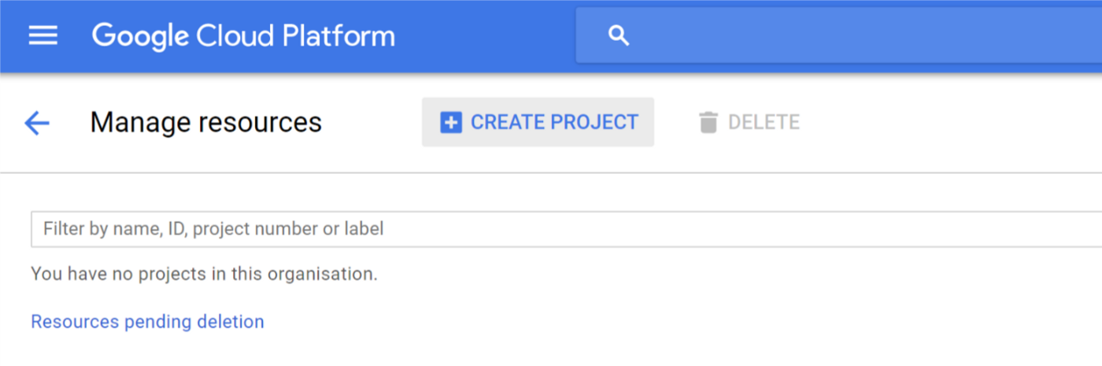

1. **Set region and zone to the following settings**

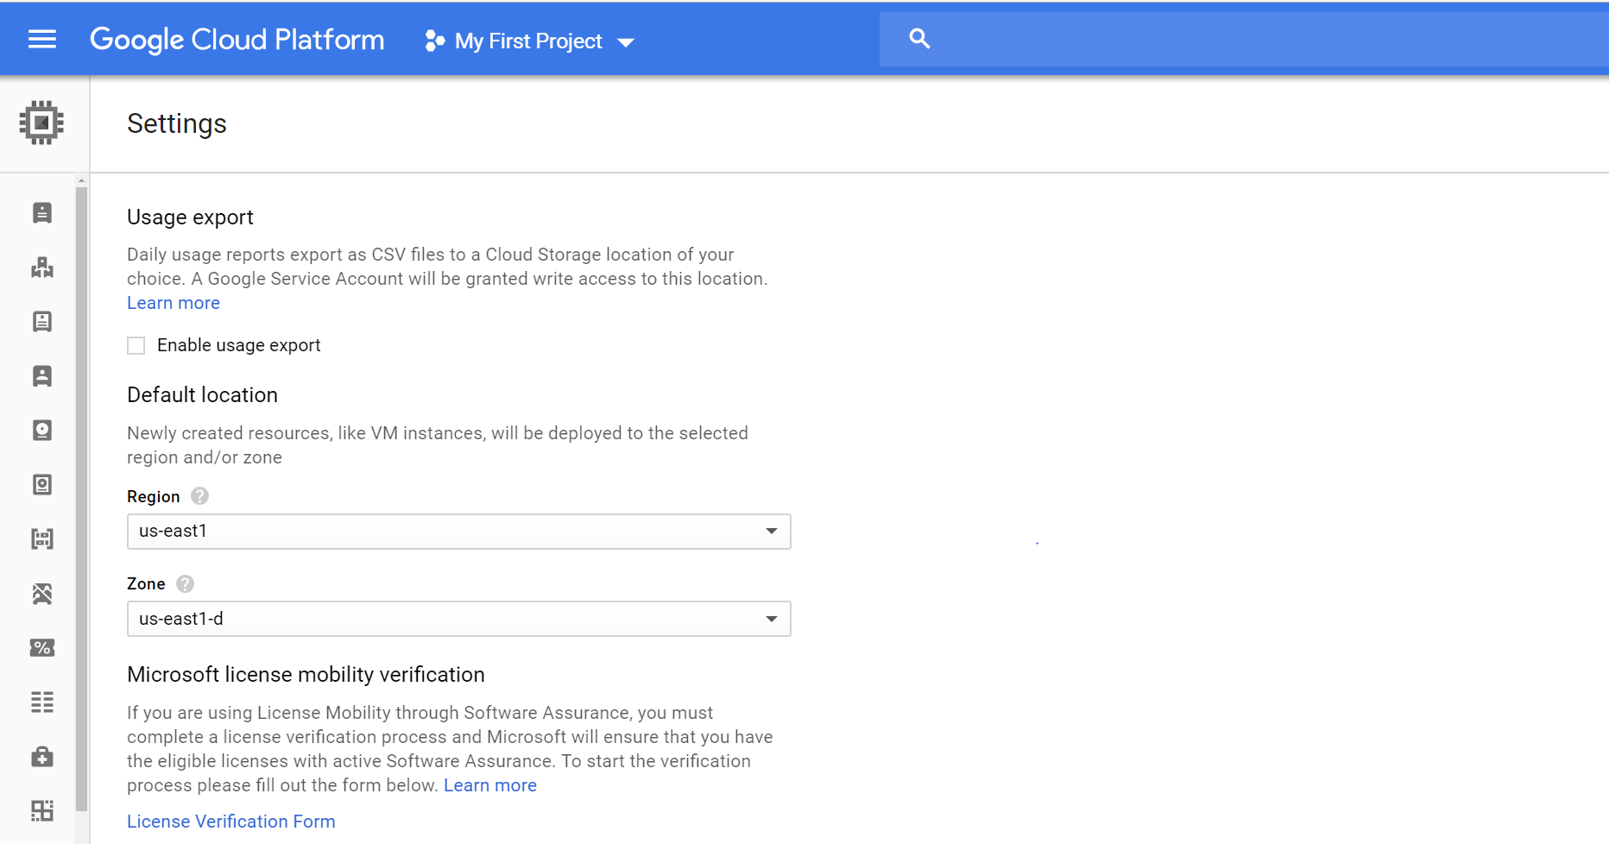

Navigate to Compute Engine then Settings. Only certain zones have NVIDIA GPUs available, us-east1-d is one of them.

1. **Configure firewall for Jupyter Notebook**

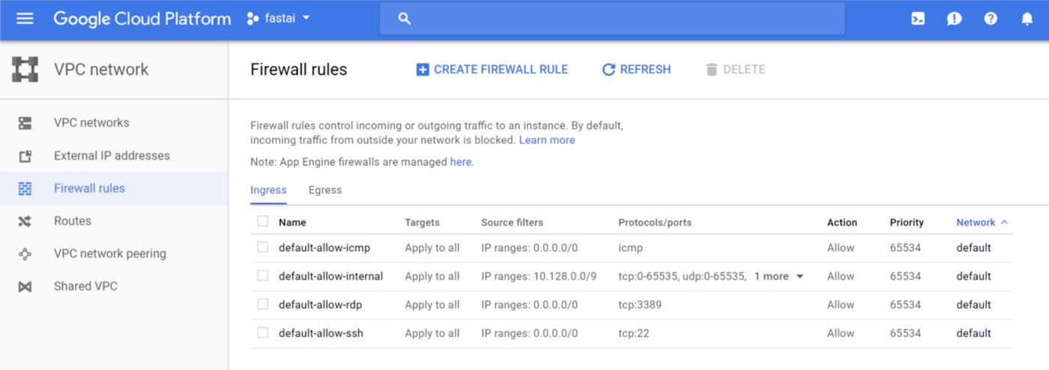

Navigate to VPC Network, then Firewall rules

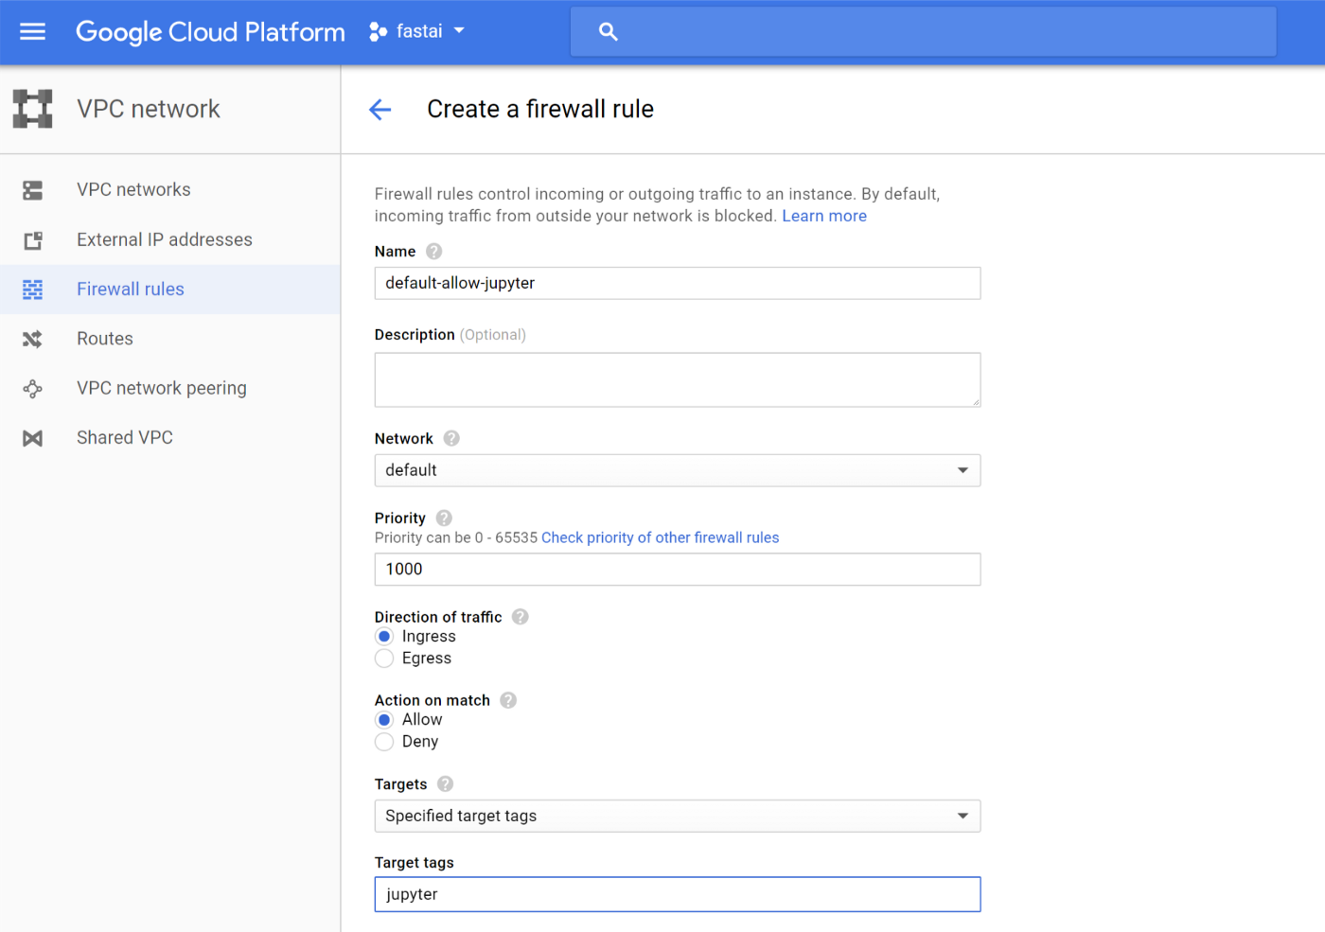

Create a firewall rule if your project does not already have one for tcp:8888

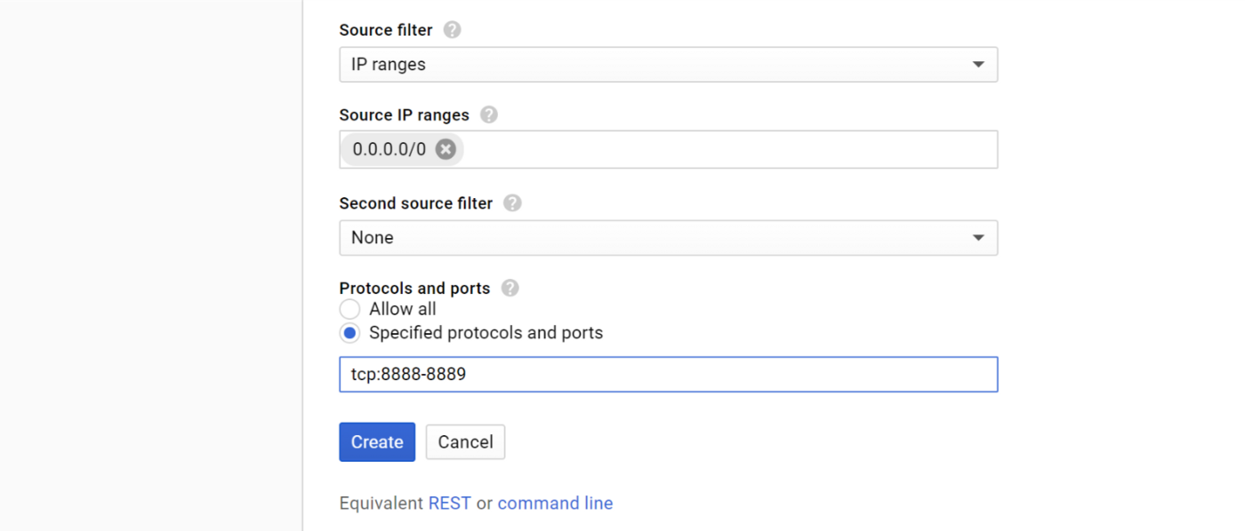

You can choose other unused port numbers, but the typical choice is 8888.

1. **Create your virtual machine instance**

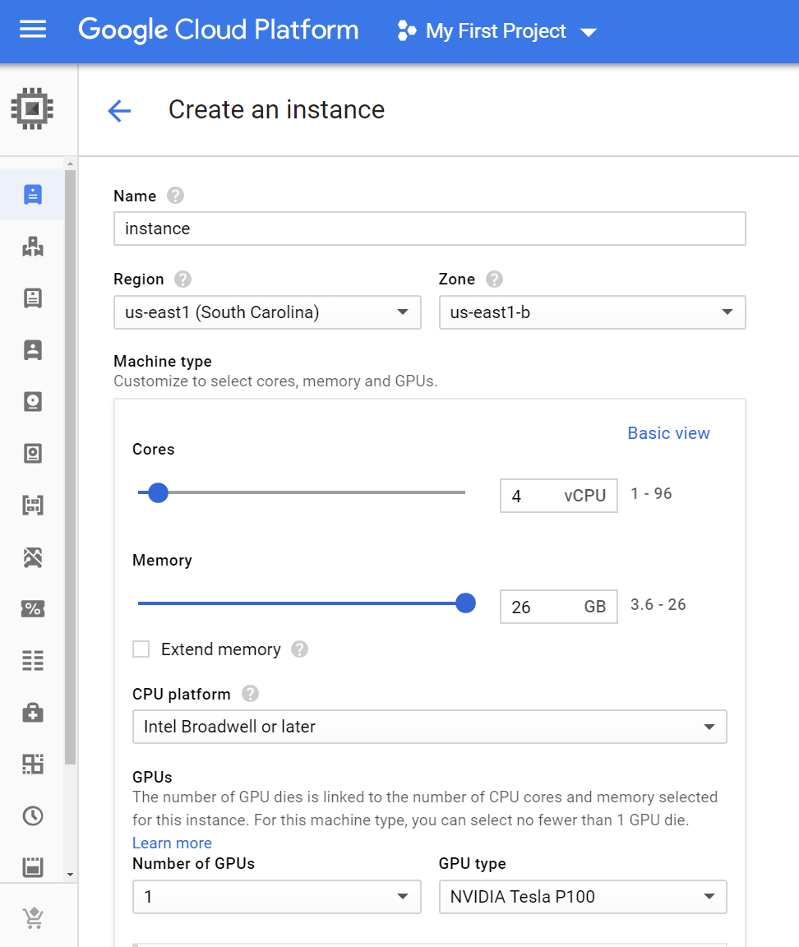

Navigate to Compute Engine, then VM instances, then Create. Set to the settings above. CPU platform Intel Broadwell or later. 1 GPU.

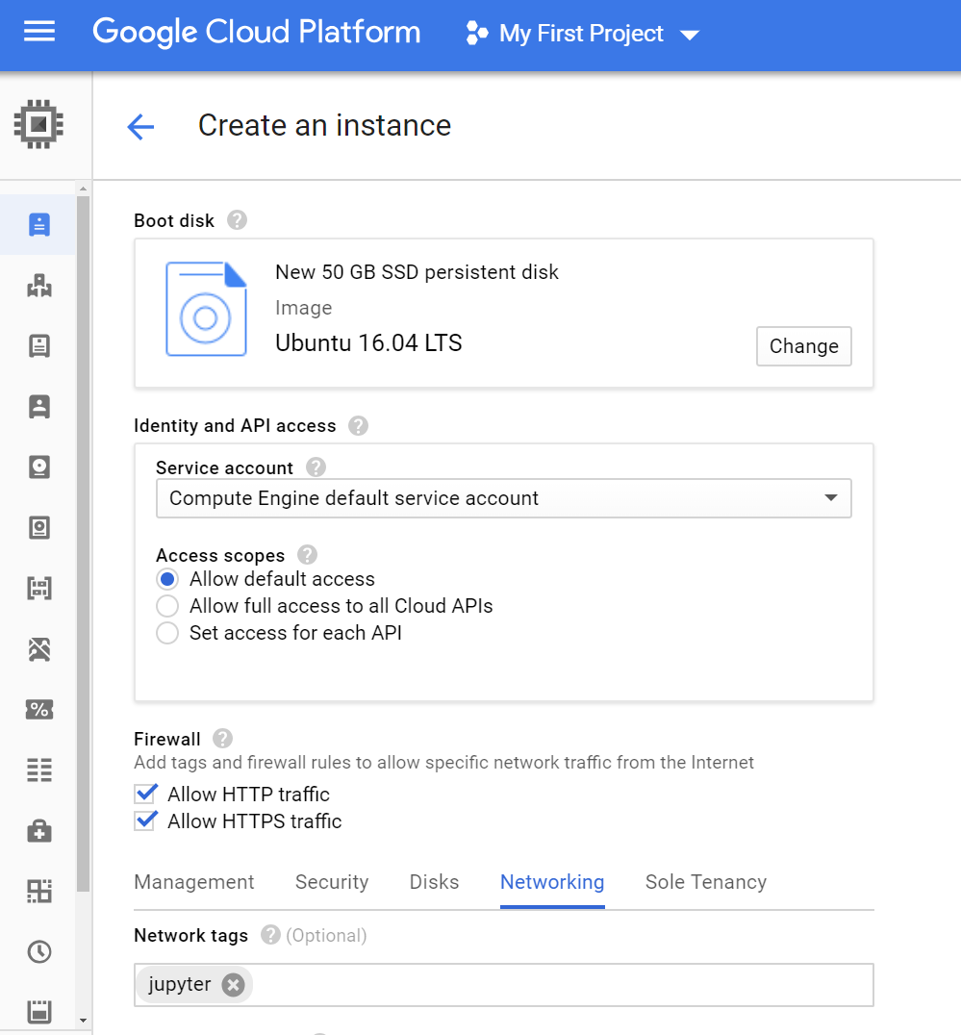

Set to the settings above. Boot disk Ubuntu 16.04 LTS and 50 GB SSD. Check both for Firewall. Drop down Networking tab and add “jupyter”

1. **Convert IP address to static**

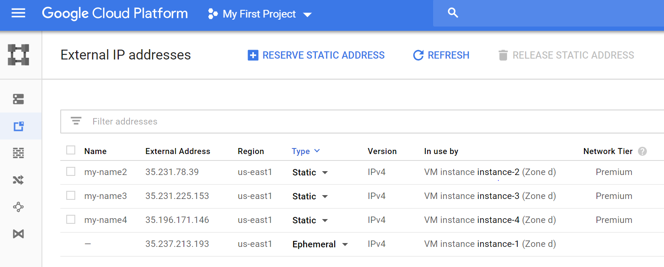

Navigate to VPC network, then External IP addresses. Convert IP address to “Static” and give it a name.

1. **Connect to VM instance via Google Cloud SDK**

**a**. [Download](https://cloud.google.com/sdk/docs/) and install Cloud Tools for your OS to use the Cloud SDK. (Windows users: check the option to install Python during installation).

**b**. Run “gcloud init” to link your account, and select project and region.

**c**. Run “gcloud compute ssh <your instance name>”

1. **Run the following bash setup script**

curl https://raw.githubusercontent.com/howkhang/fastai-v2-setup/master/setup.sh | bash

You will be automatically disconnected after the script has finished running in order for the VM to do a reboot.

1. **Connect to Jupyter notebook**

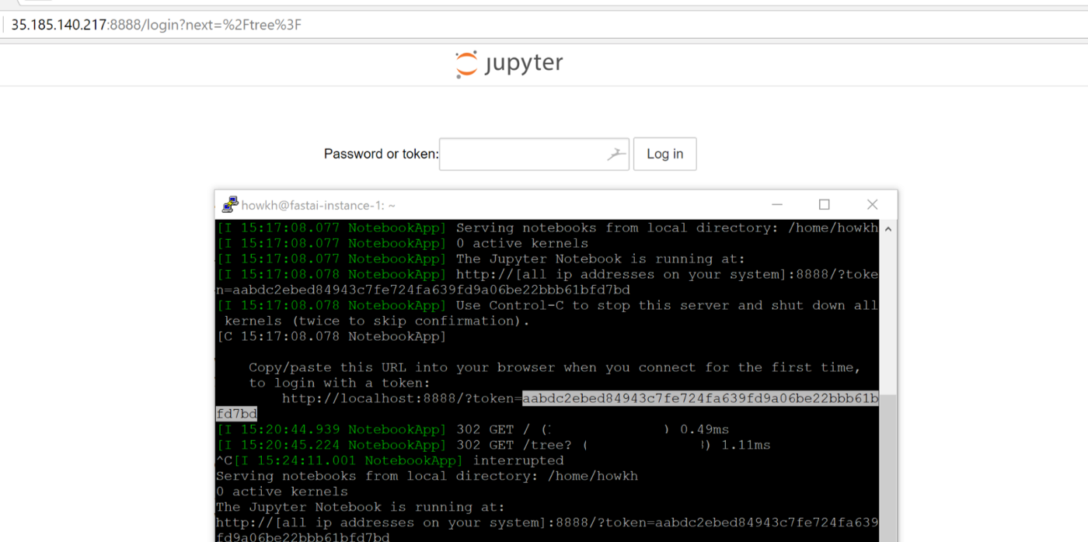

Launch your browser and connect with your VM’s static IP address followed by the port number (in this case, “:8888”). For the token, copy the long string of characters shown after the “token=”

1. **Finished!**

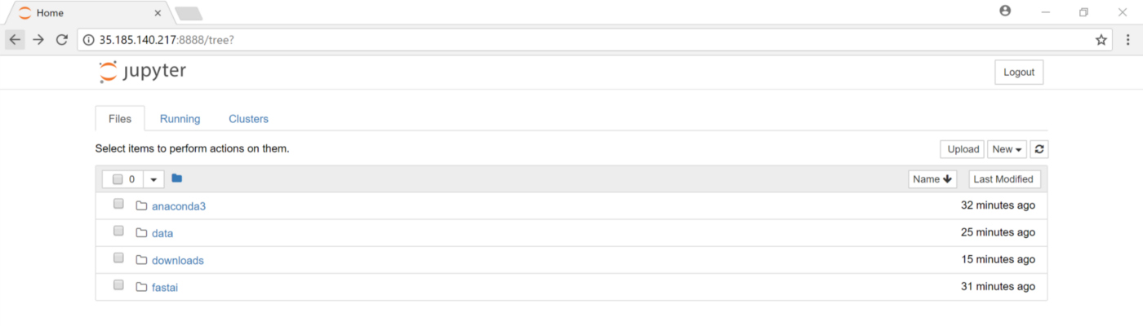

**TO STOP ACCRUING CHARGES**

1. Remember to STOP your VM instance on the instances page in Compute Engine.
2. Release the static IP address. In your command line, use

gcloud compute addresses delete [ADDRESS_NAME]

where [ADDRESS_NAME] is the name of the static IP address

Note: If you want to connect to VM instance again after you release its IP address, you will need to make your static IP address again and redo step 6. It costs 0.01 per hour for reserving at static IP address so release it whenever most convenient.